**JAVA ASSIGNMENT : 3**

1. **How to convert string to date in java program**

**PROGRAM :**

**import java.text.SimpleDateFormat;**

**import java.util.Date;**

**public class StringToDate {**

**public static void main(String[] args) {**

**String dateString = "2022-12-31";**

**SimpleDateFormat dateFormat = new SimpleDateFormat("yyyy-MM-dd");**

**try {**

**Date date = dateFormat.parse(dateString);**

**System.out.println("Input String: " + dateString);**

**System.out.println("Output Date: " + date);**

**} catch (Exception e) {**

**System.out.println("Error occurred: " + e.getMessage());**

**}**

**}**

**}**

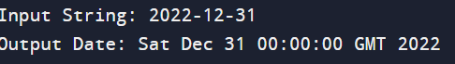

1. **How to convert integer to string, string to long, string to float, string to double in java program.**

**PROGRAM:**

**public class DataConversion {**

**public static void main(String[] args) {**

**// Convert integer to string**

**int numInt = 123;**

**String strInt = String.valueOf(numInt);**

**// Convert string to long**

**String strLong = "456";**

**long numLong = Long.parseLong(strLong);**

**// Convert string to float**

**String strFloat = "78.9";**

**float numFloat = Float.parseFloat(strFloat);**

**// Convert string to double**

**String strDouble = "101.345";**

**double numDouble = Double.parseDouble(strDouble);**

**System.out.println("Integer to String: " + strInt);**

**System.out.println("String to Long: " + numLong);**

**System.out.println("String to Float: " + numFloat);**

**System.out.println("String to Double: " + numDouble);**

**}**

**}**

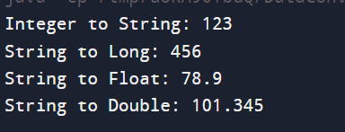

**3.How to Date format in java Program**

**PROGRAM:**

**import java.text.SimpleDateFormat;**

**import java.util.Date;**

**public class DateFormatExample {**

**public static void main(String[] args) {**

**SimpleDateFormat sdf = new SimpleDateFormat("dd/MM/yyyy HH:mm:ss");**

**Date date = new Date();**

**String formattedDate = sdf.format(date);**

**System.out.println("Formatted Date: " + formattedDate);**

**}**

**}**



**4.** **How to print date and time in java Program**

**PROGRAM:**

**import java.util.Date;**

**public class DateTimePrinter {**

**public static void main(String[] args) {**

**Date date = new Date();**

**System.out.println("Current Date and Time: " + date);**

**}**

**}**



**5.** **Check Given No is palindrome or Not in java Program**

**PROGRAM:**

**import java.util.Scanner;**

**public class PalindromeCheck {**

**public static void main(String[] args) {**

**Scanner scanner = new Scanner(System.in);**

**System.out.print("Enter a number: ");**

**int number = scanner.nextInt();**

**int originalNumber = number;**

**int reversedNumber = 0;**

**while (number != 0) {**

**int digit = number % 10;**

**reversedNumber = reversedNumber * 10 + digit;**

**number /= 10;**

**}**

**if (originalNumber == reversedNumber) {**

**System.out.println(originalNumber + " is a palindrome number.");**

**} else {**

**System.out.println(originalNumber + " is not a palindrome number.");**

**}**

**scanner.close();**

**}**

**}**

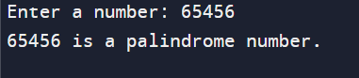

**6.** **Find All substring of string in java Program**

**PROGRAM:**

**public class SubstringFinder {**

**public static void main(String[] args) {**

**String str = "hello";**

**for (int i = 0; i < str.length(); i++) {**

**for (int j = i + 1; j <= str.length(); j++) {**

**System.out.println(str.substring(i, j));**

**}**

**}**

**}**

**}**

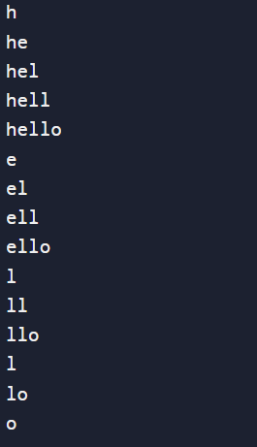

**7.Print Floyd’s Triangle in java Program**

**PROGRAM:**

**public class FloydTriangle {**

**public static void main(String[] args) {**

**int rows = 5;**

**int number = 1;**

**for (int i = 1; i <= rows; i++) {**

**for (int j = 1; j <= i; j++) {**

**System.out.print(number + " ");**

**number++;**

**}**

**System.out.println();**

**}**

**}**

**}**

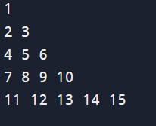

**8.** **Print Multiplication table Program in java**

**PROGRAM:**

**public class MultiplicationTable {**

**public static void main(String[] args) {**

**int num = 9;**

**for(int i = 1; i <= 10; i++) {**

**System.out.printf("%d * %d = %d \n", num, i, num * i);**

**}**

**}**

**}**

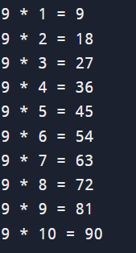

**9.** **Print prime no Program in java**

**PROGRAM:**

**public class PrimeNumbers {**

**public static void main(String[] args) {**

**int n = 50;**

**System.out.println("Prime numbers between 1 and " + n + " are:");**

**for (int i = 2; i <= n; i++) {**

**if (isPrime(i)) {**

**System.out.print(i + " ");**

**}**

**}**

**}**

**public static boolean isPrime(int num) {**

**if (num <= 1) {**

**return false;**

**}**

**for (int i = 2; i <= Math.sqrt(num); i++) {**

**if (num % i == 0) {**

**return false;**

**}**

**}**

**return true;**

**}**

**}**

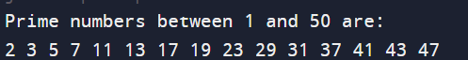

**10.** **Check no is Armstrong or not in java Program**

**PROGRAM:** **import java.util.Scanner;**

**public class ArmstrongNumber {**

**public static void main(String[] args) {**

**int number, originalNumber, remainder, result = 0;**

**Scanner scanner = new Scanner(System.in);**

**System.out.print("Enter a number to check if it is an Armstrong number: ");**

**number = scanner.nextInt();**

**originalNumber = number;**

**while (originalNumber != 0) {**

**remainder = originalNumber % 10;**

**result += Math.pow(remainder, 3);**

**originalNumber /= 10;**

**}**

**if (result == number)**

**System.out.println(number + " is an Armstrong number.");**

**else**

**System.out.println(number + " is not an Armstrong number.");**

**}**

**}**

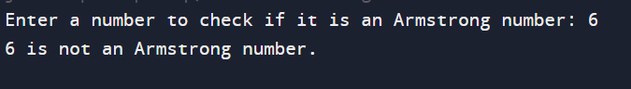

**11.** **Find factorial for given no Program in Java**

**PROGRAM:**

**import java.util.Scanner;**

**public class Main {**

**public static void main(String[] args) {**

**Scanner scanner = new Scanner(System.in);**

**System.out.print("Enter a number: ");**

**int number = scanner.nextInt();**

**long factorial = 1;**

**for (int i = 1; i <= number; i++) {**

**factorial *= i;**

**}**

**System.out.println("Factorial of " + number + " is: " + factorial);**

**}**

**}**

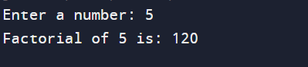

**12.** **How to check Odd and Even Number in java**

**PROGRAM:**

**import java.util.Scanner;**

**public class OddEvenChecker {**

**public static void main(String[] args) {**

**Scanner input = new Scanner(System.in);**

**System.out.print("Enter a number: ");**

**int number = input.nextInt();**

**if (number % 2 == 0) {**

**System.out.println(number + " is an even number.");**

**} else {**

**System.out.println(number + " is an odd number.");**

**}**

**input.close();**

**}**

**}**

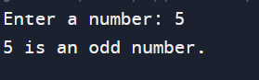

**13.** **How to swap 2 no using 3 rd variable Program in java**

**PROGRAM:**

**public class SwapNumbers {**

**public static void main(String[] args) {**

**int firstNumber = 10;**

**int secondNumber = 20;**

**System.out.println("Before swapping:");**

**System.out.println("First number: " + firstNumber);**

**System.out.println("Second number: " + secondNumber);**

**int temp = firstNumber;**

**firstNumber = secondNumber;**

**secondNumber = temp;**

**System.out.println("\nAfter swapping:");**

**System.out.println("First number: " + firstNumber);**

**System.out.println("Second number: " + secondNumber);**

**}**

**}**

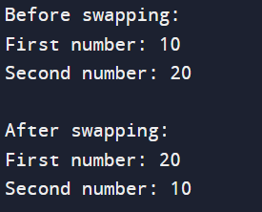

**14.** **How to multiply two matrix in java Program**

**PROGRAM:**

**public class MatrixMultiplication {**

**public static void main(String[] args) {**

**int[][] firstMatrix = {{1, 2, 3}, {4, 5, 6}, {7, 8, 9}};**

**int[][] secondMatrix = {{9, 8, 7}, {6, 5, 4}, {3, 2, 1}};**

**int rowsFirst = firstMatrix.length;**

**int columnsFirst = firstMatrix[0].length;**

**int columnsSecond = secondMatrix[0].length;**

**int[][] result = new int[rowsFirst][columnsSecond];**

**for (int i = 0; i < rowsFirst; i++) {**

**for (int j = 0; j < columnsSecond; j++) {**

**for (int k = 0; k < columnsFirst; k++) {**

**result[i][j] += firstMatrix[i][k] * secondMatrix[k][j];**

**}**

**}**

**}**

**// Displaying the result**

**for (int[] row : result) {**

**for (int column : row) {**

**System.out.print(column + " ");**

**}**

**System.out.println();**

**}**

**}**

**}**

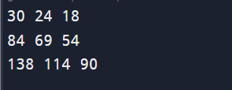

**15.** **How to add two matrix in java Program**

**PROGRAM:   
public class AddMatrices {**

**public static void main(String[] args) {**

**int[][] firstMatrix = { {1, 2, 3}, {4, 5, 6}, {7, 8, 9} };**

**int[][] secondMatrix = { {9, 8, 7}, {6, 5, 4}, {3, 2, 1} };**

**int rows = firstMatrix.length;**

**int columns = firstMatrix[0].length;**

**int[][] sum = new int[rows][columns];**

**for (int i = 0; i < rows; i++) {**

**for (int j = 0; j < columns; j++) {**

**sum[i][j] = firstMatrix[i][j] + secondMatrix[i][j];**

**}**

**}**

**System.out.println("Sum of the matrices:");**

**for (int i = 0; i < rows; i++) {**

**for (int j = 0; j < columns; j++) {**

**System.out.print(sum[i][j] + " ");**

**}**

**System.out.println();**

**}**

**}**

**}**

